DAILY EXPENSE TRACKER

A PROJECT REPORT

#### Submitted by

G. MOHIT SAI BALAJI [RA2211026010142]

M. ABHIRAM SAI [RA2211026010152]

L. PRAVALLIKA [RA2211026010143]

#### Under the Guidance of

## Dr. S.KRISHNAVENI

Associate Professor

Department Of Computational Intelligence

### *in partial fulfillment of the requirements* *for the degree of*

## BACHELOR OF TECHNOLOGY

## in

## COMPUTER SCIENCE ENGINEERING

## with specialization in Artificial Intelligence And Machine Learning



## DEPARTMENT OF COMPUTATIONAL INTELLIGENCE COLLEGE OF ENGINEERING AND TECHNOLOGY

SRM INSTITUTE OF SCIENCE AND TECHNOLOGY

## KATTANKULATHUR- 603 203

### MAY 2025

Department of Computational Intelligence

##### SRM Institute of Science & Technology

##### Own Work Declaration Form

This sheet must be filled in (each box ticked to show that the condition has been met). It must be signed and dated along with your student registration number and included with all assignments you submit – work will not be marked unless this is done.

To be completed by the student for all assessments

##### Degree/ Course : B. TECH (CSE AIML)

**Student Name : G.MOHIT SAI BALAJI, M. ABHIRAM SAI, L. PRAVALLIKA**

##### Registration Number : RA2211026010142, RA2211026010143, RA2211026010152

**Title of Work : DAILY ENPENSE TRACKER**

I / We hereby certify that this assessment compiles with the University’s Rules and Regulations relating to Academic misconduct and plagiarism**, as listed in the University Website, Regulations, and the Education Committee guidelines.

I / We confirm that all the work contained in this assessment is my / our own except where indicated, and that I / We have met the following conditions:

* Clearly referenced / listed all sources as appropriate
* Referenced and put in inverted commas all quoted text (from books, web, etc)
* Given the sources of all pictures, data etc. that are not my own
* Not made any use of the report(s) or essay(s) of any other student(s) either past or present
* Acknowledged in appropriate places any help that I have received from others (e.g. fellow students, technicians, statisticians, external sources)
* Compiled with any other plagiarism criteria specified in the Course handbook / University website

I understand that any false claim for this work will be penalized in accordance with the University policies and regulations.

|  |
| --- |
| **DECLARATION:** |
| I am aware of and understand the University’s policy on Academic misconduct and plagiarism and I certify that this assessment is my / our own work, except where indicated by referring, and that I have followed the good academic practices noted above. |
| If you are working in a group, please write your registration numbers and sign with the date for every student in your group. |

i



# SRM INSTITUTE OF SCIENCE AND TECHNOLOGY KATTANKULATHUR – 603 203

## BONAFIDE CERTIFICATE

Certified that 21CSP302L - Project report titled “**Daily Expense Tracker**” is the bonafide work of “**G. MOHIT SAI BALAJI [RA2211026010142], M. ABHIRAM SAI [RA2211026010152], L. PRAVALLIKA [RA2211026010143]”** who carried out the project work under my supervision. Certified further, that to the best of my knowledge the work reported herein does not form any other project report or dissertation on the basis of which a degree or award was conferred on an earlier occasion on this or any other candidate.

|  |  |
| --- | --- |
| **SIGNATURE**  Dr. S.Krishnaveni  **Supervisor**  Associate Professor  Department of Computational Intelligence  SRM Institute of Science and Technology  Kattankulathur | **SIGNATURE**  Dr. R.Annie Uthra  **Head of the Department**  Professor  Department of Computational Intelligence  SRM Institute of Science and Technology Kattankulathur |

ii

**ACKNOWLEDGEMENTS**

We express our humble gratitude to **Dr. C. Muthamizhchelvan**, Vice-Chancellor, SRM Institute of Science and Technology, for the facilities extended for the project work and his continued support.

We extend our sincere thanks to **Dr. Leenus Jesu Martin M,** Dean-CET, SRM Institute of Science and Technology, for his invaluable support.

We wish to thank **Dr. Revathi Venkataraman**, Professor and Chairperson, School of Computing, SRM Institute of Science and Technology, for her support throughout the project work.

We encompass our sincere thanks to, **Dr. M. Pushpalatha**, Professor and Associate Chairperson – CS, School of Computing and **Dr. Lakshmi,** Professor and Associate Chairperson -AI, School of Computing, SRM Institute of Science and Technology, for their invaluable support.

We are incredibly grateful to our Head of the Department, **Dr. R.Annie Uthra**, Professor, Computational Intelligence, SRM Institute of Science and Technology, for her suggestions and encouragement at all the stages of the project work.

We want to convey our thanks to our Project Coordinators, Panel Head, and Panel Members Department of Computational Intelligence, SRM Institute of Science and Technology, for their inputs during the project reviews and support.

We register our immeasurable thanks to our Faculty Advisor, **Dr.Prithi S**, Assistant Professor, Department of Computational Intelligence, SRM Institute of Science and Technology, for leading and helping us to complete our course.

Our inexpressible respect and thanks to our guide, **Dr.S.Krishnaveni**, Associate Professor, Department of Computational Intelligence, SRM Institute of Science and Technology, for providing us with an opportunity to pursue our project under her mentorship. She provided us with the freedom and support to explore the research topics of our interest. Her passion for solving problems and making a difference in the world has always been inspiring.

We sincerely thank all the staff members of Computational Intelligence, School of Computing, S.R.M Institute of Science and Technology, for their help during our project. Finally, we would like to thank our parents, family members, and friends for their unconditional love, constant support and encouragement

G. Mohit Sai balaji

M. Abhiram Sai

L. Pravallika

iii

### **ABSTRACT**

### This project presents the development of an Expense Forecasting System, integrated into an AI-driven web-based expense tracking platform using Django. The system is designed to predict a user’s future expenses based on their historical spending patterns, thereby assisting them in better financial planning and management. It retrieves the latest expense records of a user, processes the data using Pandas, and applies an ARIMA (AutoRegressive Integrated Moving Average) model to forecast expenses for the next 30 days. The project also generates visualizations using Matplotlib, showcasing both the past and predicted expenses on a timeline to provide clear insights. Additionally, a category-wise breakdown of previous spending is calculated to highlight areas where the user spends the most. The system incorporates robust error handling, ensuring a smooth user experience even when limited data is available. Forecast results, visual plots, and expenditure summaries are displayed on a dedicated forecasting page, enhancing usability. Overall, this project combines data analysis, machine learning, and interactive visualization to create a powerful tool that empowers users to track, predict, and make informed decisions about their financial future.

### iv

**TABLE OF CONTENTS**

**ABSTRACT iv**

**TABLE OF CONTENTS v**

**LIST OF FIGURES vi**

**LIST OF TABLES vii**

**ABBREVIATIONS viii**

**CHAPTER NO.**  **TITLE**  **PAGE NO.**

**1 INTRODUCTION 1**

1.1 Introduction to Project 1

1.2 Motivation 1

1.3 Sustainable Development Goal of the Project 2 1.4 Product Vision Statement 3

1.5 Product Goal 5

1.6 Product Backlog (Key User Stories with Desired Outcomes) 5

1.7 Product Release Plan 7

**2** **SPRINT PLANNING AND EXECUTION 8**

**2.1** **Sprint 1 8** 2.1.1 Sprint Goal with User Stories of Sprint 1 8

2.1.2 Functional Document 11

2.1.3 Architecture Document 16

2.1.4 UI Design 19

2.1.5 Functional Test Cases 21

2.1.6 Daily Call Progress 21

2.1.7 Committed vs Completed User Stories 22

2.1.8 Sprint Retrospective 22

v

**2.2 Sprint 2 23**

2.2.1 Sprint Goal with User Stories of Sprint 2 23

2.2.2 Functional Document 23

2.2.3 Architecture Document 27

2.2.4 UI Design 30

2.2.5 Functional Test Cases 32

2.2.6 Daily Call Progress 32

2.2.7 Committed vs Completed User Stories 33

2.2.8 Sprint Retrospective 33

**3.** **RESULTS AND DISCUSSIONS 34**

3.1 Project Outcomes (Justification of outcomes and how they align 34

with the goals)

3.2 Committed vs Completed User Stories 39

**4 CONCLUSIONS & FUTURE ENHANCEMENT 40**

**APPENDIX 41**

**A. SAMPLE CODING 41**

vi

**LIST OF FIGURES**

|  |  |  |
| --- | --- | --- |
| **CHAPTER NO.** | **TITLE** | **PAGE NO.** |
| 1.1 | MS Planner Board of daily expense tracker | 7 |
| 1.2 | Release plan | 7 |
| 2.1 | bucket for user registration | 9 |
| 2.2 | bucket for editing expenses and categorization | 10 |
| 2.3 | Bucket for data visualization | 11 |
| 2.4 | System Architecture Diagram | 17 |
| 2.5 | UI Design for Login page | 19 |
| 2.6 | UI design for editing and categorizing expenses | 20 |
| 2.7 | UI design for dashboard | 20 |
| 2.8 | Standup meetings | 21 |
| 2.9 | Bar graph for Committed Vs Completed User Stories | 22 |
| 2.10 | use case diagram | 28 |
| 2.11 | ER diagram | 30 |
| 2.12 | UI design for Expense categorization | 30 |
| 2.13 | UI design for multiple currencies | 31 |
| 2.14 | UI design for Expense Forecast | 31 |
| 2.15 | standup meetings 2 | 32 |
| 2.16 | Committed vs Completed user stories sprint 2 | 33 |
| 3.1 | login page | 34 |
| 3.2 | Expense logging | 34 |
| 3.3 | Expense Summary | 35 |
| 3.4 | Expense Report | 35 |
| 3.5 | Report Export | 36 |
| 3.6 | Forecast Expense | 36 |
| 3.7 | Income Dashboard | 37 |
| 3.8 | Preferred Currencies | 37 |
| 3.9 | Committed Vs Completed User stories | 39 |

vii

**LIST OF TABLES**

|  |  |  |
| --- | --- | --- |
| CHAPTER NO. | TITLE | PAGE NO. |
| 1.1 | User Stories | 5 |
| 2.1 | Detailed User Stories of sprint 1 | 8 |
| 2.2 | Access Level Authorization Matrix | 15 |
| 2.3 | Detailed Functional Test Case | 21 |
| 2.4 | Sprint Retrospective for the Sprint 1 | 22 |
| 2.5 | User stories for sprint 2 | 23 |
| 2.6 | Access Level Authorization Matrix | 26 |
| 2.7 | Functional test cases sprint 2 | 32 |
| 2.8 | Sprint Retrospective for the Sprint 1 | 33 |

viii

**ABBREVIATIONS**

|  |  |
| --- | --- |
| **Abbreviation** | **Full Form** |
| AI | Artificial Intelligence |
| UX | User Experience |
| UI | User Interface |
| DB | Database |
| API | Application Programming Interface |
| JWT | JSON Web Token |
| SQL | Structured Query Language |
| SRS | Software Requirements Specification |
| SDG | Sustainable Development Goals |
| CRUD | Create, Read, Update, Delete |
| SSL | Secure Sockets Layer |
| GDPR | General Data Protection Regulation |
| AWS | Amazon Web Services |
| CSV | Comma-Separated Values |
| ML | Machine Learning |
| KPI | Key Performance Indicator |
| ETL | Extract, Transform, Load |
| SaaS | Software as a Service |
| MVC | Model-View-Controller |
| OTP | One-Time Password |
| HTTPS | HyperText Transfer Protocol Secure |
| SMTP | Simple Mail Transfer Protocol |
| ROI | Return on Investment |
| CI/CD | Continuous Integration / Continuous Deployment |
| CDN | Content Delivery Network |

ix

**CHAPTER 1**

**INTRODUCTION**

**1.1 Introduction to Project:**

In today’s dynamic financial landscape, managing personal expenses effectively has become essential for ensuring long-term economic stability. Most traditional expense tracking applications only allow users to record their past transactions without providing actionable insights about their future financial behavior. Recognizing this limitation, the Expense Forecasting System was conceptualized and developed to empower users with predictive insights about their spending patterns.

The system, built using Django and powered by machine learning models such as ARIMA (AutoRegressive Integrated Moving Average), forecasts future expenditures based on a user's historical spending data. By providing a 30-day expense forecast along with category-wise analysis and graphical visualizations, the platform enables users to make informed, proactive financial decisions. This approach shifts financial management from being merely reactive to becoming predictive and strategic, offering a significant value addition over conventional tracking tools.

**1.2 Motivation**

* The motivation behind this project arises from the observation that many individuals, especially students, young professionals, and those new to financial independence, struggle with budgeting and financial planning. Unexpected expenses, lack of awareness about spending habits, and poor anticipation of future needs often result in financial instability.
* Existing tools typically offer dashboards and spending summaries but fail to provide users with a forecast that could aid in future financial planning. By applying machine learning algorithms to predict expenses, users are not only made aware of their historical patterns but are also equipped with a forward-looking perspective on their financial future.
* Furthermore, in an era where data-driven decision-making is becoming the norm across industries, introducing predictive analytics into personal finance management bridges an important technological gap. The desire to create a simple yet powerful system that fosters better financial habits and literacy served as the primary driving force behind the development of this project.

**1.3 Sustainable Development Goal of the Project**

* This project directly contributes to **Sustainable Development Goal 8: Decent Work and Economic Growth** by promoting financial literacy and supporting economic empowerment at an individual level. Financial literacy is fundamental to fostering sustainable economic growth, as it equips individuals with the knowledge and tools needed to make sound financial decisions, avoid debt traps, and invest in their future.
* By helping users predict and manage their expenditures more effectively, the system contributes to building financial resilience, reducing economic vulnerabilities, and promoting sustainable livelihoods. Additionally, the project indirectly supports **Goal 12: Responsible Consumption and Production** by encouraging users to be more conscious of their spending habits and to plan their consumption based on realistic projections rather than impulsive behaviors.
* In the broader context, empowering individuals with predictive financial tools lays the foundation for more stable and resilient communities. It showcases how innovative technology can be harnessed to create not just smarter applications but also to foster meaningful societal change aligned with the global agenda for sustainable development.

**1.4 Product Vision Statement**

AUDIENCE

* Primary Audience: Individuals aiming for better personal financial management, including students, professionals, and families seeking to predict and plan their expenses more efficiently.
* Secondary Audience: Financial advisors and budgeting consultants looking for tools to assist clients in forecasting expenditures and improving financial discipline.

NEEDS

* Primary Needs:
  + Accurate forecasting of future personal expenses based on historical spending data.
  + Visualization tools such as graphs to make trends and forecasts easy to understand.
  + Category-wise analysis to identify areas of overspending and potential savings.
* Secondary Needs:
  + Historical tracking and analysis of spending habits over time.
  + Tools for setting financial goals based on forecasted expenses.
  + Notification or alert system for expense milestones or forecast deviations.

PRODUCTS

* Core Product:  
  An AI-powered expense forecasting platform using time-series models (like ARIMA) to predict future spending, visualize trends, and assist users in financial planning.
* Additional Features:
  + Graphical representation of past and forecasted expenses for better insights.
  + Category-specific expenditure breakdowns.
  + Secure, user-specific dashboards displaying historical and predicted financial data.
  + Future integration possibilities: Budget suggestions, expense reminders, and goal setting.

VALUES

* Core Values:
  + Financial Awareness: Empowering users with insights into their spending habits and future expenses.
  + Predictive Planning: Helping users anticipate their financial needs rather than react to them.
  + Accessibility: Providing an easy-to-use platform that makes financial forecasting simple and intuitive.
* Differentiators:
  + Machine Learning Forecasting: Using ARIMA and predictive analytics for more accurate, data-driven financial forecasting.
  + User-centric Design: Tailoring insights and forecasts specifically for each user's unique spending pattern.
  + Data Visualization: Offering clear and interactive visual tools to enhance user understanding and engagement.

**1.5 Product Goal**

* The goal of the Expense Forecasting System is to empower individuals to take control of their financial future by providing accurate, AI-driven predictions of their upcoming expenses. By analyzing users' historical spending patterns, the system aims to generate reliable 30-day expense forecasts, offer category-wise expenditure insights, and visualize financial trends in an intuitive and accessible manner.
* The platform aspires to make financial planning proactive rather than reactive, enabling users to budget more effectively, identify unnecessary expenditures, and set informed financial goals. Through the integration of time-series modeling (ARIMA) and user-centric dashboards, the system promotes financial literacy, encourages smarter spending habits, and ultimately helps users achieve greater financial stability and awareness.
* In the long term, the product seeks to expand by incorporating smart suggestions, budget tracking, and goal-oriented savings plans, thus offering a comprehensive and sustainable personal finance management solution.

**1.6 Product Backlog**

Table 1.1 User Stories

|  |  |
| --- | --- |
| **S.NO.** | **USER STORIES OF DAILY EXPENSE TRACKER** |
| 1 | As a user, I want to register and log in securely so that I can access my personal expense data. |
| 2 | As a user, I want to add an expense with details like amount, category, and date so that I can track my spending. |
| 3 | As a user, I want to view my total expenses for the month so that I can manage my budget effectively. |
| 4 | As a user, I want AI-driven insights into my spending patterns so that I can optimize my expenses. |
| 5 | As a user, I want to share expenses with friends so that we can track shared costs together. |
| 6 | As a user, I want to export my expense data to CSV/PDF so that I can keep records for tax or auditing purposes. |
| 7 | As a user, I want to receive reminders about upcoming bills and spending limits so that I can stay on top of my finances. |
| 8 | Users can add expenses in various currencies with automatic conversion. |
| 9 | As a user, I want to categorize my expenses with customizable tags so that I can better organize and analyze my spending habits. |
| 10 | As a user, I want to set monthly budgets for different categories so that I can control overspending in specific areas. |

From Table 1.1,The product backlog for the Daily expense tracker consists of a prioritized list of features and improvements, including expense data integration, implementing the ARIMA forecasting model, creating an interactive user dashboard, visualizing forecasts and category-wise expenses, building notifications for budget limits, and ensuring secure user authentication. This backlog is continuously refined based on user feedback to ensure the development aligns with the project’s goals and delivers valuable functionality to users.

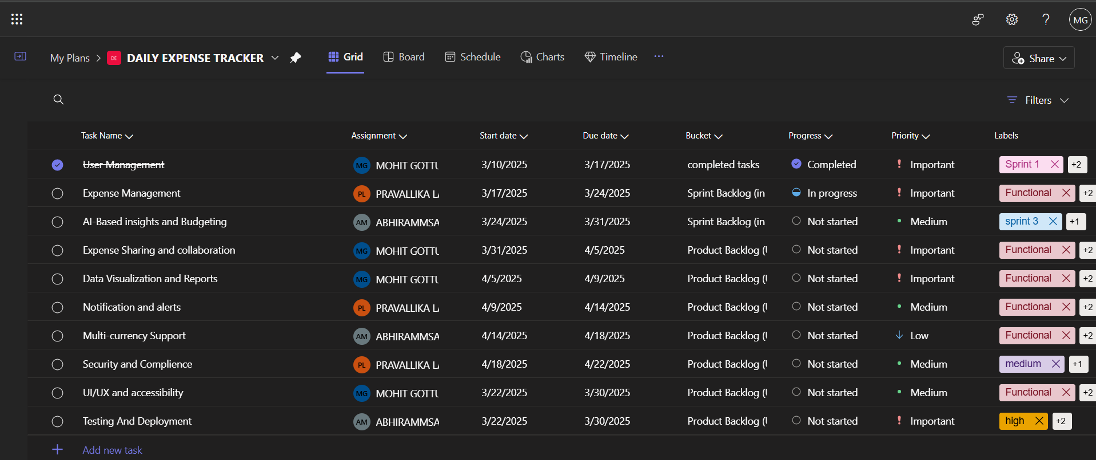Figure 1.1 MS Planner Board of daily expense tracker

Figure 1.1 shows the Sprint planning which we have done using MS planner

**1.7 Product Release Plan**

The following Figure 1.2 depicts the release plan of the project

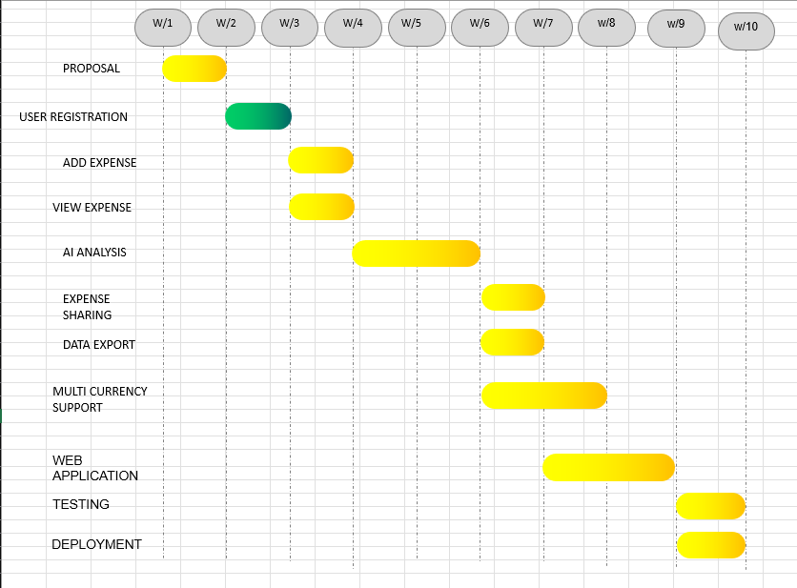

Figure 1.2 Release plan

Figure 1.2 represents the expected Time line of the entire Project. The Project as per figure 1.2 is expected to be completed in a span of 8 weeks

**CHAPTER 2**

**SPRINT PLANNING AND EXECUTION**

**2.1 Sprint 1**

**2.1.1 Sprint Goal with User Stories of Sprint 1**

The goal of the first sprint is to lay the foundation for the "Daily Expense Tracker" application, focusing on user registration, profile creation, and setting up essential functionalities for expense management. The sprint will also include developing the user interface and essential features for adding and categorizing expenses.The following table 2.1 represents the detailed user stories of the sprint 1

Table 2.1 Detailed User Stories of sprint 1

|  |  |
| --- | --- |
| **S.NO** | **Detailed User Stories** |
| US #1 | As a new user, I want to easily register for the platform so that I can access its features such as profile creation and expense tracking. |
| US #2 | As a new user, I want to create a personal profile after registration, so that I can store my financial information and track expenses. |
| US #3 | As a user, I want to add my daily expenses with details like amount, date, and category so that I can track my spending over time. |
| US #4 | As a user, I want to categorize my expenses (e.g., food, transportation, entertainment) so that I can analyze spending in specific areas. |
| US #5 | As a user, I want a dashboard that shows my total expenses and spending trends so that I can easily monitor my financial activity. |

Table 2.1 represents the user stories which are considered for sprint 1.It Consists of 5 user stories which mainly focused on user registration and management.

Planner Board representation of user stories are mentioned below figures 2.1,2.2 and 2.3

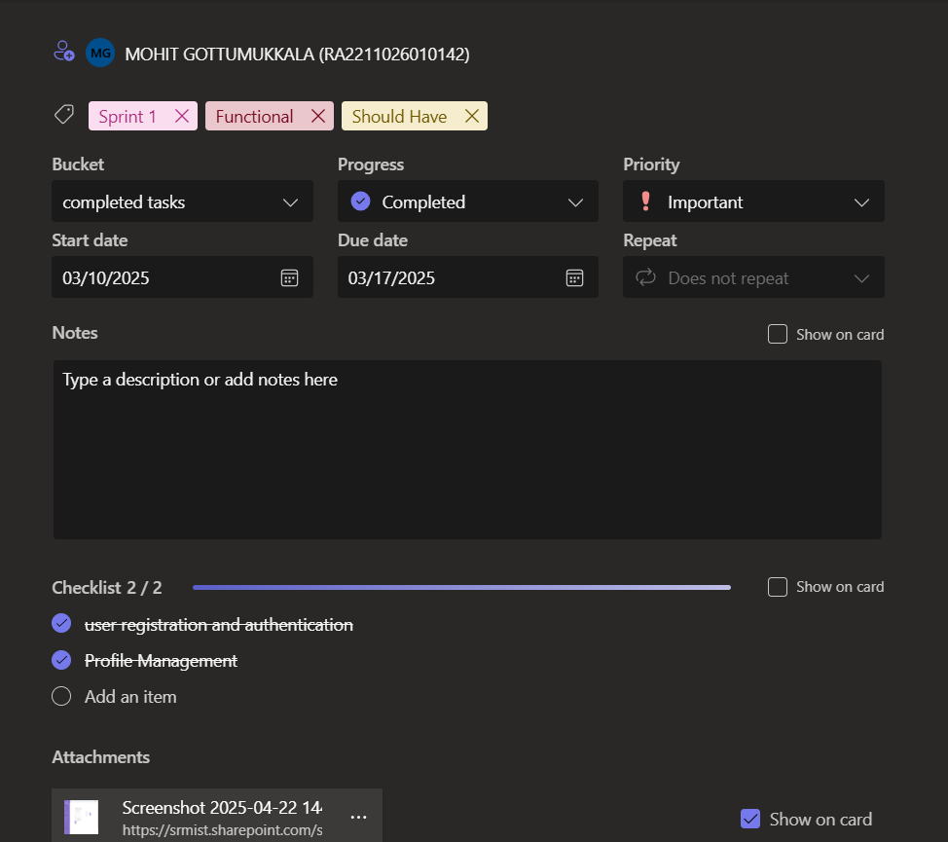

Figure 2.1 bucket for user registration

Figure 2.1 represents the Bucket For user registration which have sub tasks of authentication and profile management.

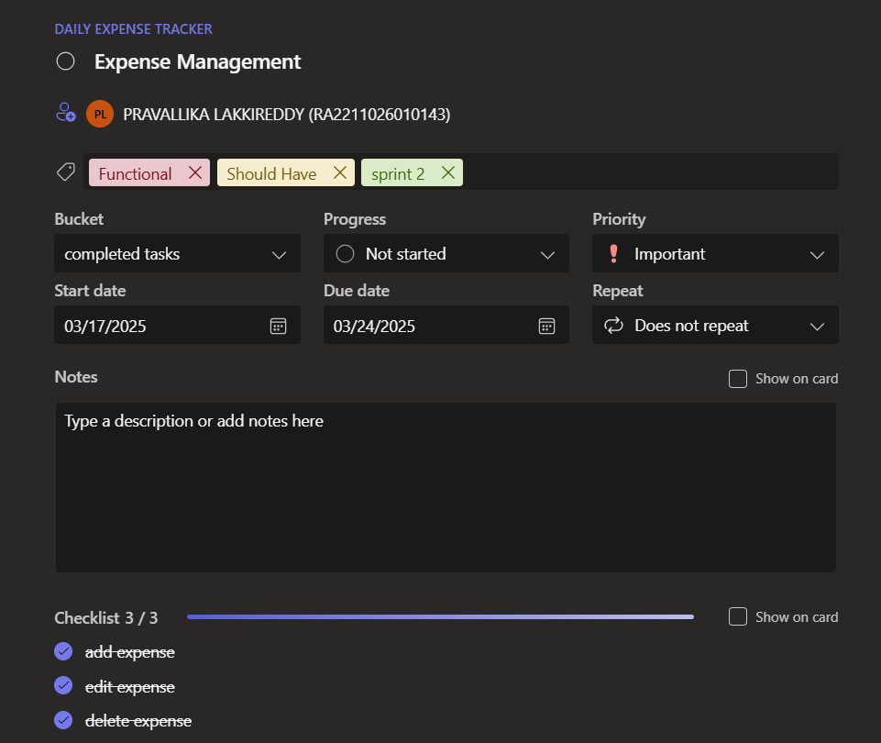

Figure 2.2 bucket for editing expenses and categorization

Figure 2.2 depicts the bucket created in MS planner to manage the expense logging process.

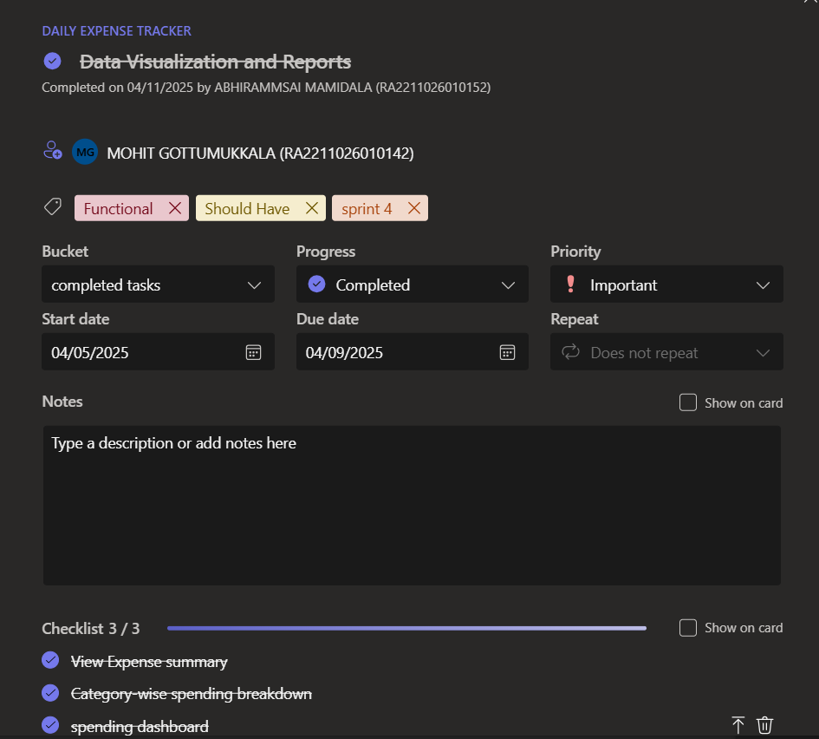

Figure 2.3 Bucket for data visualization

Figure 2.3 represents the Bucket for data visualization part which includes expense summary and visualization dashboards.

**2.1.2 Functional Document**

2.1.2.1 Introduction

The Daily Expense Tracker project aims to develop a user-friendly platform that helps individuals efficiently manage and track their daily expenses. The application leverages artificial intelligence to provide budget insights, forecasts, and categorization of expenses. It allows users to maintain a detailed record of their spending habits, provides real-time analytics, and offers notifications and alerts to help users make informed financial decisions. This project seeks to empower users to take control of their finances through an intuitive and interactive user experience.

2.1.2.2 Product goal

The primary goal of this project is to build a platform that enables users to track, analyze, and manage their daily expenses with ease. Key objectives include:

* Expense Management: Enabling users to add, categorize, and track expenses.
* AI-based Insights: Providing budget recommendations, expense forecasts, and actionable insights based on user spending habits.
* Expense Sharing: Allowing users to share expenses with others for collaborative financial management.
* Data Visualization: Presenting detailed visual reports and trends on user spending.
* Multi-currency Support: Supporting various currencies for global accessibility.
* Security & Compliance: Ensuring the highest level of security and regulatory compliance for user data.

2.1.2.3 Demography (users, location)

Users:

* Target Users: Individuals seeking to manage their daily finances, including students, working professionals, and families.
* User Characteristics: Varying financial literacy levels, age groups, and diverse geographical backgrounds.

Location:

* Target Location: Global, focusing on regions with a strong internet presence and interest in personal finance management.
* Languages: Multi-language support for accessibility across different regions.

2.1.2.4 BUSINESS PROCESSES

The key business processes for the Daily Expense Tracker include:

* User Registration and Authentication:
  + Users can register through email or social media accounts.
  + Authentication ensures that personal financial data is securely accessed.
* Expense Addition and Categorization:
  + Users can add daily expenses, specifying the amount, date, and category (e.g., food, transportation).
* Expense Forecasting and Insights:
  + The AI model analyzes spending patterns to provide forecasts and suggestions for budget optimization.
* Expense Sharing:
  + Users can share specific expenses with others, facilitating shared financial tracking for groups (e.g., roommates, families).

2.1.2.5 Features

This project focuses on implementing the following key features:

Feature 1: User Registration and Profile Creation

1. Description:
   * The platform allows users to securely register and create a personalized profile for tracking their expenses.
2. User Story:
   * As a user, I want to register on the platform and create my profile so I can begin tracking my daily expenses.

Feature 2: Expense Tracking and Categorization

1. Description:
   * Users can add their daily expenses and categorize them (e.g., groceries, transportation, entertainment).
2. User Story:
   * As a user, I want to add my daily expenses and categorize them to track where I’m spending money.

Feature 3: AI-based Expense Insights

1. Description:
   * The platform uses AI to analyze user expenses and provides insights into spending habits, budget recommendations, and savings suggestions.
2. User Story:
   * As a user, I want to receive insights and suggestions based on my spending patterns so I can make better financial decisions.

Feature 4: Expense Sharing

1. Description:
   * Users can share their expenses with others (e.g., in the case of shared bills) for easier collaboration.
2. User Story:
   * As a user, I want to share my expenses with others so we can track shared costs effectively.

Feature 5: Multi-Currency Support

1. Description:
   * The platform supports multiple currencies for users across different regions.
2. User Story:
   * As an international user, I want to track my expenses in my local currency, so I can accurately manage my finances.

Feature 6: Data Visualization and Reports

1. Description:
   * The platform provides visual representations of spending patterns, including charts and graphs, to make financial data more digestible.
2. User Story:
   * As a user, I want to see a breakdown of my spending habits in visual format so I can better understand my financial situation.

2.1.2.6 Authorization matrix

Table 2.2: Access Level Authorization Matrix

|  |  |
| --- | --- |
| Role | Access Level |
| **Administrator** | Full access to all platform features, user management, expense management, and platform settings. |
| **User** | Access to expense tracking, categorization, insights, budget recommendations, and sharing features. |
| **Guest User** | Limited access to view public expenses and reports (without adding or modifying data). |

Table 2.2 Represents the access level authorization matrix for the roles of administrator, User, Guest User.

2.1.2.7 Assumptions

* Data Availability: User expense data will be consistently logged and available for analysis.
* Cloud Infrastructure: The platform will leverage cloud-based servers for reliable storage and performance.
* User Feedback: Users will provide feedback during beta testing to refine features.
* Regulatory Compliance: The platform will adhere to relevant data privacy laws (e.g., GDPR, CCPA) to ensure secure handling of financial data.

**2.1.3 Architecture Document**

2.1.3.1 Application

Microservices:

The Daily Expense Tracker platform is built using a microservices architecture, which ensures scalability, flexibility, and ease of maintenance. Each core functionality is encapsulated in independent services. Key services include:

* Authentication Service: Manages user registration, login, two-factor authentication (2FA), and password recovery.
* Expense Management Service: Handles the addition, editing, deletion, and categorization of expenses, as well as storing expense data in the database.
* Budgeting and Insights Service: Provides AI-based insights, budgeting recommendations, and expense forecasting based on user data.
* Expense Sharing Service: Manages the functionality for users to share their expenses with others (e.g., group expenses).
* Notification Service: Sends alerts, notifications, and reminders to users about their expenses, budget limits, and other important updates.
* Data Visualization Service: Generates reports, charts, and graphs to visualize user spending habits and financial trends.

2.1.3.2 System Architecture

The system is structured into the following layers:

1. Frontend Layer:
   * User Interface (UI): A responsive web interface (built using frameworks like React or Angular) that allows users to interact with the application. This layer includes features for expense tracking, categorization, and viewing reports.
2. API Gateway:
   * API Gateway: Handles all requests from the frontend, routing them to the appropriate microservices. It also manages authentication, authorization, and load balancing.
3. Backend Layer:
   * Microservices: Each core service (as mentioned above) operates independently and communicates with the database or other services as needed.
   * Database: A relational database (e.g., PostgreSQL) stores user data, expense records, budget data, and historical records.
   * AI & Analytics Engine: An AI-powered engine (possibly using Python’s scikit-learn or TensorFlow) that processes user data to provide insights and forecasts.
4. Third-party Integrations:
   * Currency Exchange API: Provides multi-currency support by converting expenses into the user’s selected currency.

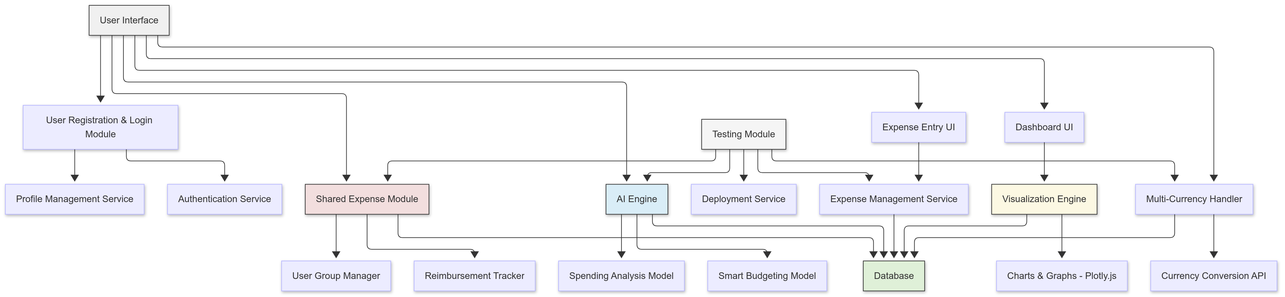Figure 2.4: System Architecture Diagram

Figure 2.4 represents the microservices system architecture diagram of the entire project.

2.1.3.3 Data Exchange Contract

Frequency of Data Exchanges:

Data exchanges are designed to support real-time and periodic operations based on the system's needs:

* Real-Time Exchanges:
  + User authentication and authorization (via login).
  + Real-time expense data updates (when users add, edit, or delete expenses).
  + Notifications and alerts (e.g., budget limits, expense tracking reminders).
* Periodic Syncs:
  + Synchronization of historical expense data for generating monthly reports or expense summaries.
  + Periodic backup of user data and expense records to ensure data integrity.

Data Sets:

The platform manages several key data sets that require specific exchange strategies:

* User Data: Contains personal details, login credentials, and preferences. This data is exchanged during user registration, login, and profile updates.
* Expense Data: Includes information about user expenses, such as amount, date, category, and associated user. This data is exchanged in real-time when users add or modify expenses.
* Budget and Insight Data: Contains budgeting goals, AI-generated insights, and forecasts. This data is exchanged when users set budget limits or request financial advice.
* Notification Data: Tracks real-time alerts, budget reminders, and expense notifications. This data is exchanged whenever notifications are triggered by user actions or system processes.

Mode of Exchanges (API, File, Queue, etc.):

Different methods of data exchange are used based on the type and frequency of data:

* API: RESTful APIs are employed to facilitate real-time communication between the frontend (UI) and backend services. For example, APIs are used to send user data, expense data, and budget information between the client and the server.
* Message Queues: Services like RabbitMQ or AWS SQS are used for background tasks such as sending notifications, processing expense reports, and running AI-driven insights asynchronously.
* File-Based Exchanges: Some operations, such as bulk data uploads (e.g., importing multiple expenses or CSV files), may use file-based exchanges, typically leveraging cloud storage services like AWS S3 for uploading and storing large data files.

**2.1.4 UI design**

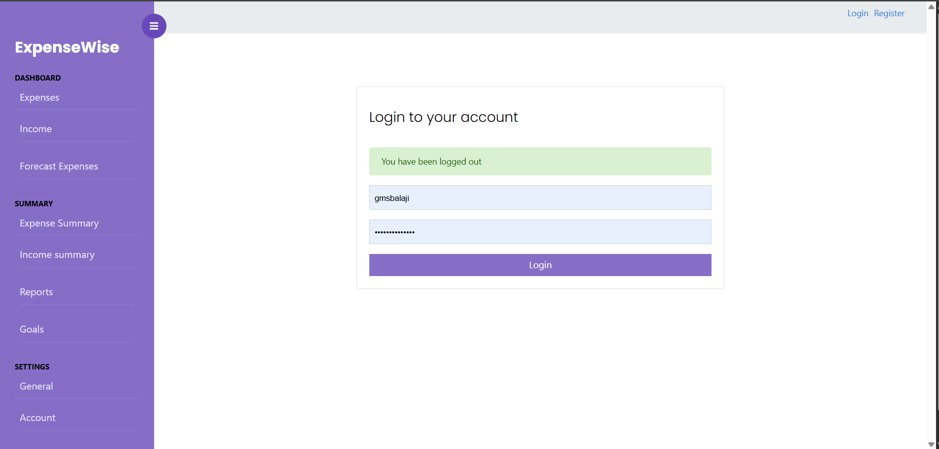

Figure 2.5 UI Design for Login page

Figure 2.5 represents the UI design of Login page. It contains the spaces to enter the correct username and password.

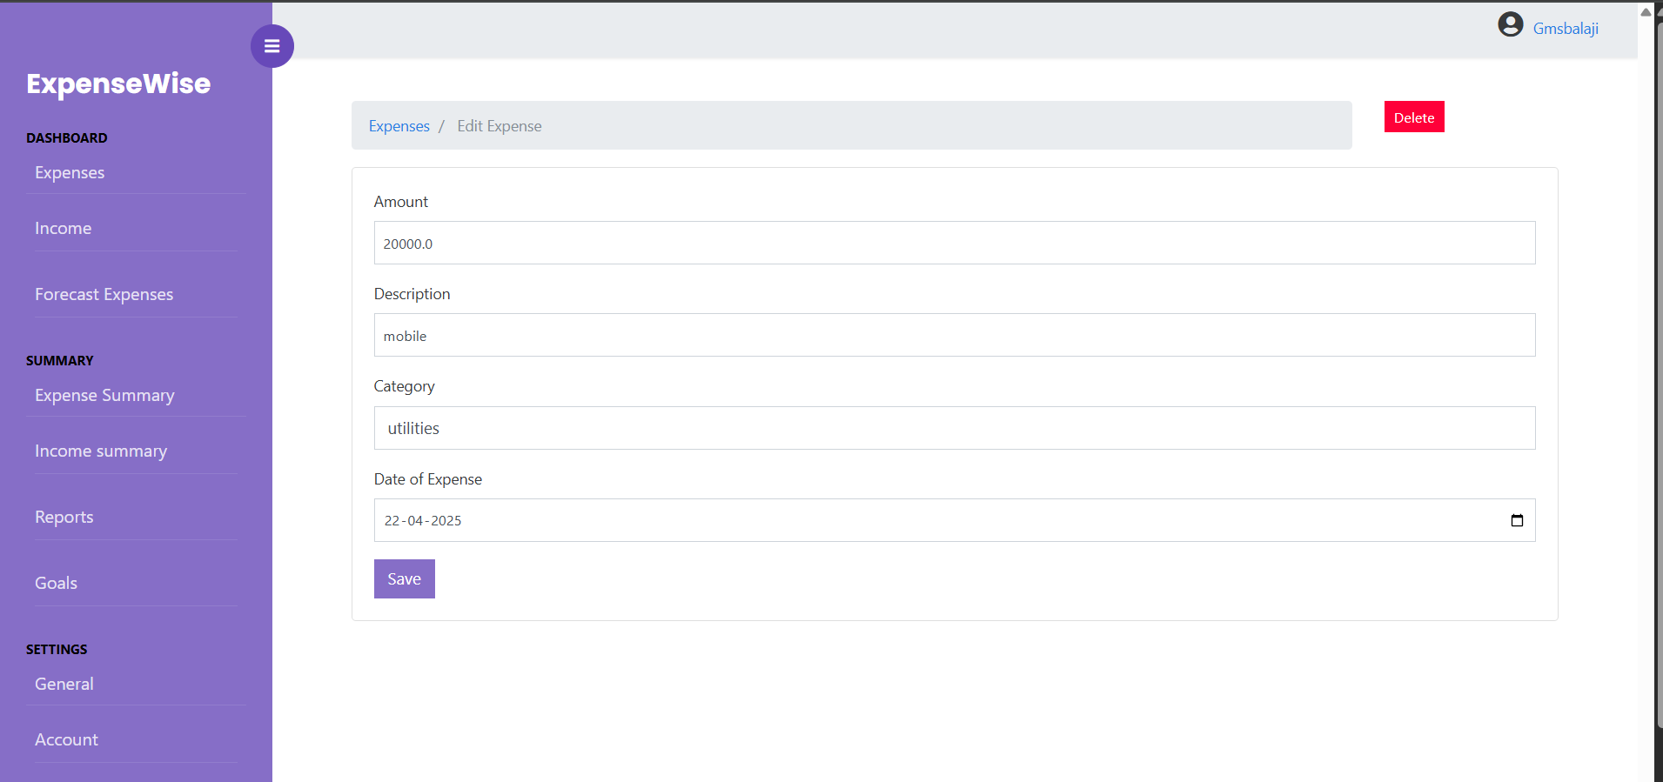

Figure 2.6 UI design for editing and categorizing expenses

Figure 2.6 represents the UI design for managing the expense logging .

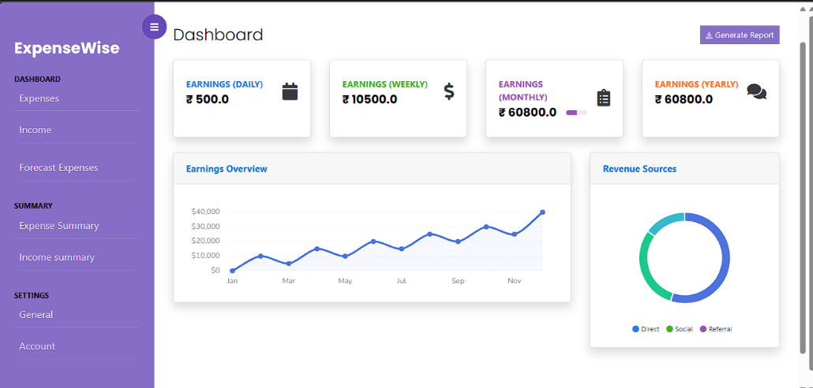

Figure 2.7 UI design for dashboard

Figure 2.7 represents the UI design to create a income tracking dashboard.It contains a graph tacking the income and separate sections for income logging over separate period of times.

**2.1.5 Functional Test Cases**

Table 2.3 Detailed Functional Test Case

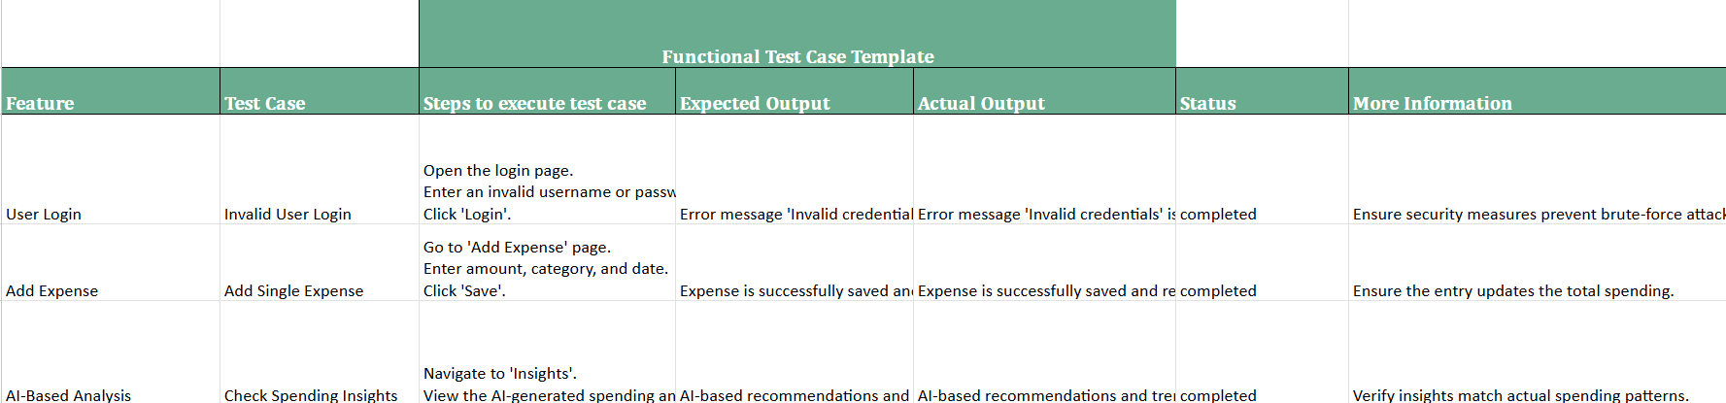

Table 2.3 represents the Detailed Functional test Cases of the sprint 1.

**2.1.6 Daily Call Progress**

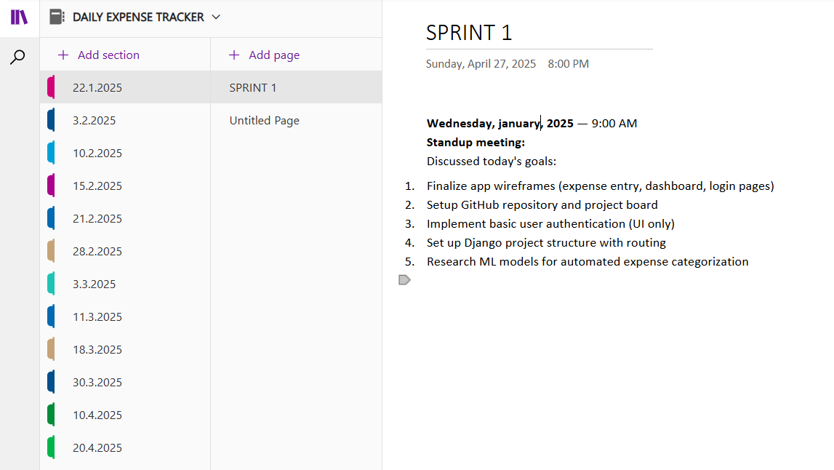

Figure 2.8 Standup meetings

Figure 2.8 represents the daily scrum meetings we had over the period of time to discuss about the sprint progress.

**2.1.7 Committed Vs Completed User Stories**

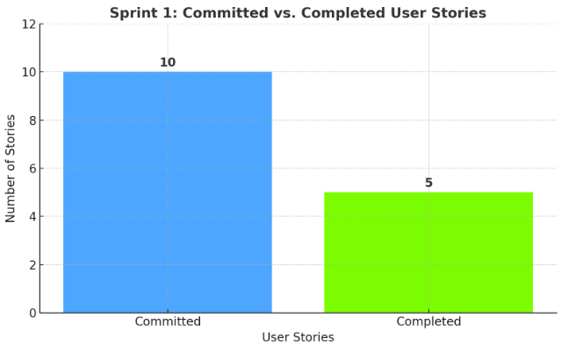

Figure 2.9 Bar graph for Committed Vs Completed User Stories

From figure 2.9 we can say that out of 10 user stories we managed to complete 5 user stories successfully.

**2.1.8 Sprint Retrospective**

Table 2.4 Sprint Retrospective for the Sprint 1

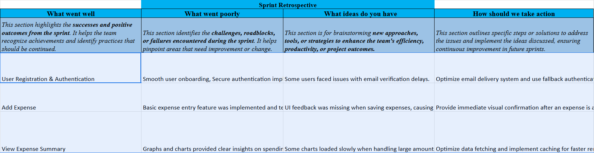

Table 2.4 represents the sprint retrospective for the sprint 1

**2.2 SPRINT 2**

**2.2.1 Sprint Goal with User Stories of Sprint 2**

The goal of the second sprint is to enhance the functionality of the Daily Expense Tracker by implementing core features such as AI-based insights, expense sharing and collaboration, data visualization, and setting up multi-currency support. The aim is to enable users to not only track their expenses but also get intelligent insights, collaborate on shared expenses, visualize their spending trends, and manage expenses in different currencies.

Table 2.5 User stories for sprint 2

|  |  |
| --- | --- |
| **S.NO** | **Detailed User Stories** |
| US #1 | As a user, I want to see AI-based insights on my spending habits so that I can manage my finances better. |
| US #2 | As a user, I want to set a budget and receive alerts if I am nearing my limit so that I can control my spending. |
| US #3 | As a user, I want to share my expenses with others so that we can collaborate and track shared financial activities. |
| US #4 | As a user, I want to view my expenses in multiple currencies, so I can track my spending in different currencies when traveling. |
| US #5 | As a user, I want to see visual reports (graphs and charts) of my expenses by category and over time to better understand my spending trends. |
| US #6 | As a user, I want to be able to categorize my expenses and view breakdowns of where I am spending the most money. |

Table 2.5 represents the user stories which are considered for sprint 2

**2.2.2 Functional Document**

2.2.2.1 Introduction

The second sprint of the Daily Expense Tracker project is focused on implementing advanced features such as AI-based insights, multi-currency support, and collaborative expense sharing. These features aim to enhance user experience by providing valuable insights into spending patterns, enabling seamless collaboration with others on shared expenses, and supporting multi-currency transactions for a more versatile and global user base. Additionally, the sprint will focus on delivering data visualization capabilities, which allow users to visualize their spending trends and make more informed financial decisions.

2.2.2.2 Product Goal

The primary goal of this sprint is to extend the platform’s functionality by:

* Implementing AI-driven insights for better expense management.
* Enabling users to set budgets and receive notifications when nearing their limit.
* Supporting multi-currency tracking for global users.
* Introducing expense sharing for collaboration among users.
* Providing rich visualizations (graphs, charts) for expense breakdowns and trends.

2.2.2.3 Demography (Users, Location)

* Users:
  + Target Users: Individuals (students, professionals, families) who wish to track and manage their personal finances, as well as small businesses that require a simple tool for expense tracking and collaboration.
  + User Characteristics: Varying levels of financial literacy, diverse income sources, and different financial goals. Users may be single or part of groups that share expenses.
* Location:
  + Target Location: Global, particularly focusing on regions with diverse currency systems (e.g., North America, Europe, and Asia) and users who frequently travel or manage finances across multiple countries.

2.2.2.4 Business Processes

Key business processes for this sprint include:

* Expense Tracking:
  + Users can add, categorize, and track their personal expenses.
  + Expenses are updated in real-time and synced with the cloud.
* AI-Based Insights:
  + The system analyzes user spending patterns to provide personalized recommendations.
  + The AI will also predict future spending based on historical data.
* Expense Sharing:
  + Users can share individual expenses or total expense categories with others (e.g., group sharing for travel or household expenses).
  + The platform will track each person’s share and calculate individual contributions.
* Multi-Currency Support:
  + Expenses in different currencies will be converted to the user’s preferred currency based on real-time exchange rates.

2.2.2.5 Features

This sprint will focus on implementing the following key features:

Feature 1: AI-Based Insights

1. Description:
   * The platform will provide AI-powered insights into user spending habits, predicting future expenses and offering tips to help users stay within their budget.
2. User Story:
   * As a user, I want to see AI-based insights on my spending habits so that I can better manage my finances.

Feature 2: Expense Sharing and Collaboration

1. Description:
   * Users will be able to share their expenses with others, making it easier for groups to manage shared costs and track payments.
2. User Story:
   * As a user, I want to share my expenses with others so that we can collaborate and track shared financial activities.

Feature 3: Multi-Currency Support

1. Description:
   * The platform will support multi-currency transactions, allowing users to input expenses in different currencies and automatically convert them into the user’s preferred currency.
2. User Story:
   * As a user, I want to view my expenses in multiple currencies so I can track my spending when traveling.

Feature 4: Data Visualization and Reports

1. Description:
   * The platform will generate visual reports (e.g., bar graphs, pie charts) to represent the user’s spending by category, trends over time, and budget status.
2. User Story:
   * As a user, I want to see visual reports of my expenses by category and over time so that I can understand my spending patterns.

**2.2.2.6 Authorization Matrix**

Table 2.6 Access Level Authorization Matrix

|  |  |
| --- | --- |
| **Role** | **Access Level** |
| Administrator | Full access to manage users, expenses, budgets, and platform settings. |
| User | Access to personal expenses, budget settings, AI insights, and sharing functionalities. |
| Guest User | Limited access to view general features without personalization or expense tracking. |

Table 2.6 represents the authorization matrix for the roles of administrator, User and guest user.

**2.2.2.7 Assumptions**

* The AI models used for generating insights will require a sufficient amount of historical user data for accurate predictions.
* Multi-currency support will rely on real-time exchange rate APIs to ensure up-to-date conversions.
* Users will have stable internet access to sync their data and receive notifications in real time.
* The system will comply with relevant financial regulations and data protection laws, ensuring user privacy and security.

**2.2.3 Architecture Document**

2.2.3.1 Application

Microservices:

The Daily Expense Tracker platform continues to follow a microservices-based architecture. Each core functionality is encapsulated within independent services. The services for Sprint 2 include:

* Expense Management Service: Handles expense tracking, categorization, and management.
* AI Insights Service: Processes expense data to provide AI-based insights and recommendations.
* Expense Sharing Service: Manages collaborative expense tracking and sharing between users.
* Currency Conversion Service: Provides real-time conversion rates for multi-currency support.
* Notification Service: Sends alerts and notifications related to budget limits, expense sharing, and insights.

2.2.3.2 System Architecture

The system architecture is similar to Sprint 1, with added services and components for AI insights and multi-currency support.

1. Frontend Layer:
   * User Interface (UI): Users interact with the web interface to add expenses, view reports, set budgets, and share expenses.
2. API Gateway:
   * API Gateway: Routes all frontend requests to appropriate microservices, ensuring secure and efficient communication.
3. Backend Layer:
   * Microservices: The core services are divided into individual microservices that interact with each other through APIs.
   * Database: Relational databases store user data, expense records, and AI insights.
   * AI Engine: A machine learning model nalyses user data for predictive insights and budgeting recommendations.
4. Third-party Integrations:
   * Currency Exchange API: Provides real-time exchange rates for multi-currency support.
   * Payment Gateway Integration: Allows users to integrate payment services for expense tracking.

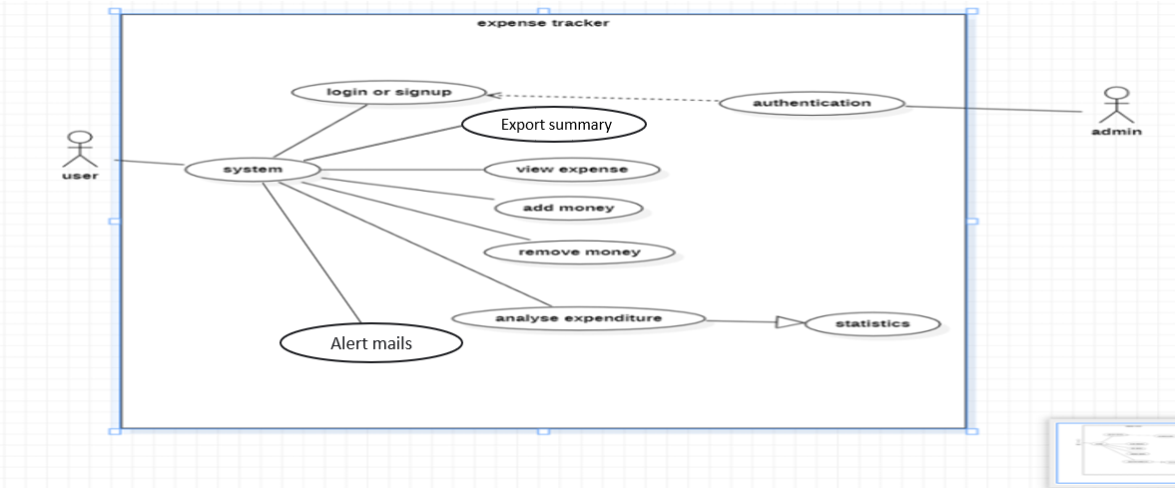

Fig 2.10 use case diagram

Figure 2.10 represents the use case diagram of the entire project.

2.2.3.3 Data Exchange Contract

Frequency of Data Exchanges:

* Real-Time Exchanges:
  + Expense tracking and updates.
  + AI insights generation.
  + Notifications and alerts.
* Periodic Syncs:
  + Syncing user activity logs for reporting and generating insights.

Data Sets:

* User Data: Personal information, preferences, login credentials.
* Expense Data: User expenses, categories, and payment methods.
* Insight Data: AI-generated insights, spending patterns, future predictions.
* Currency Data: Real-time exchange rates for multi-currency support.
* Shared Data: Expenses shared between users for collaboration.

Mode of Exchanges (API, File, Queue, etc.):

* API: RESTful APIs for real-time communication between frontend and backend.
* Message Queues: Used for handling asynchronous tasks like notification delivery.
* File-Based Exchanges: Used for bulk uploads (e.g., CSV imports of expenses).

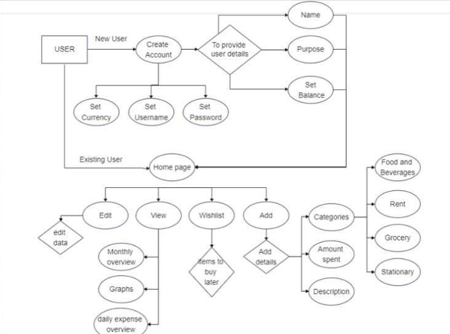

Fig 2.11 ER diagram

Figure 2.11 represents the ER diagram for the entire project explaining about the data transfers.

**2.2.4 UI Design**

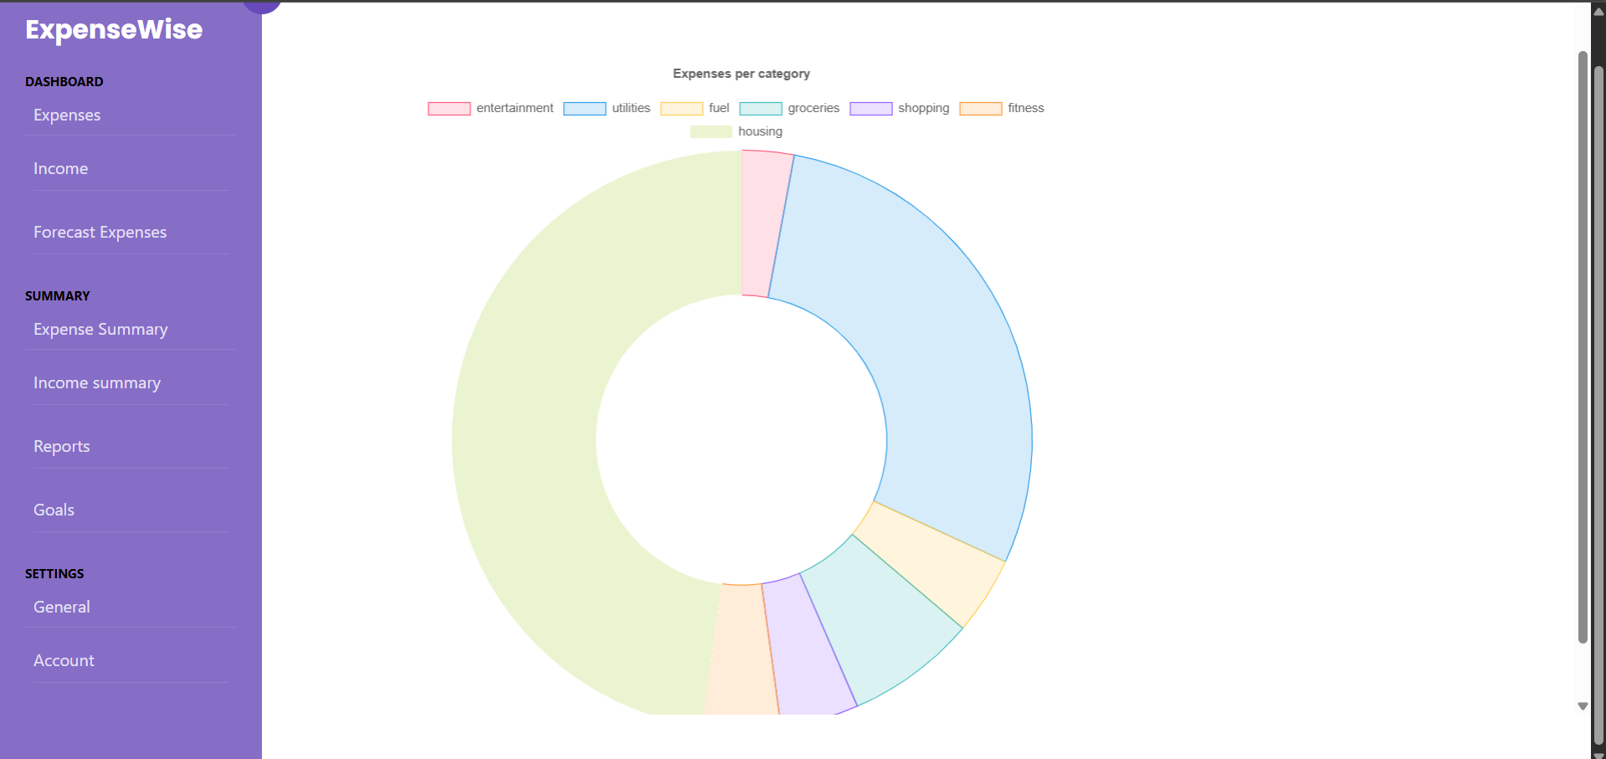

Fig 2.12 UI design for Expense categorization

Figure 2.12 represents the UI design for Expense categorizations.

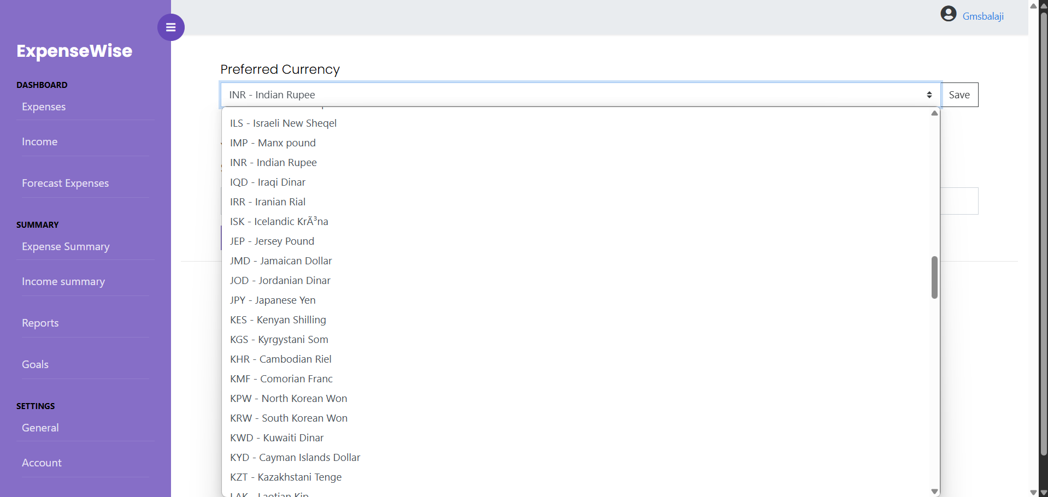

Fig 2.13 UI design for multiple currencies

Figure 2.13 represents the UI design for preferred currencies.

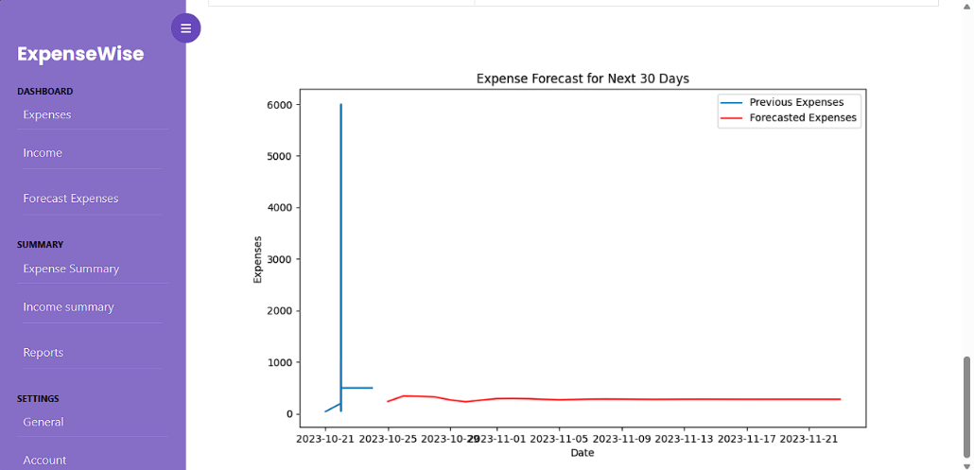

Fig 2.14 UI design for Expense Forecast

Figure 2.14 represents the UI design for Expense forecast predicting the category which you are going to spend more on.

**2.2.5 Functional Test Cases**

Table 2.7 Functional test cases sprint 2

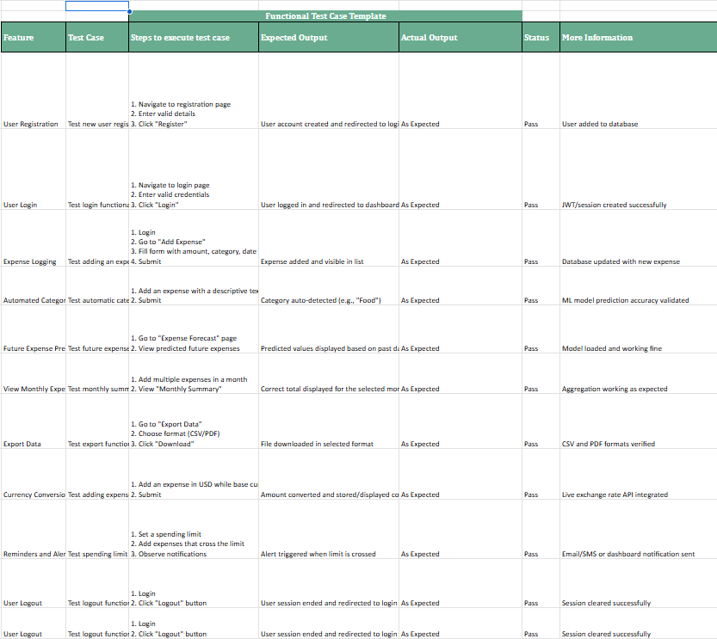

Table 2.7 represents the functional test cases for our sprint 2.

**2.2.6 Daily Call Progress**

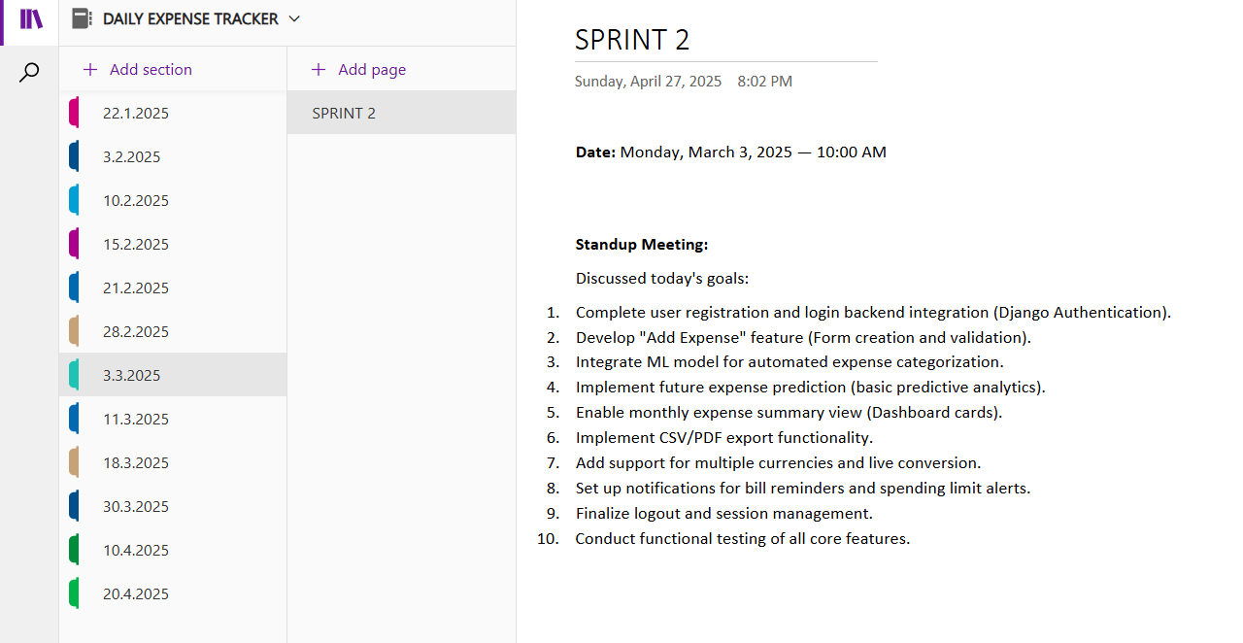

Fig 2.15 standup meetings 2

Figure 2.15 gives an idea about the sprint meetings which we had during sprint 2.

2.2.7 COMMITTED Vs COMPLETED USER STORIES

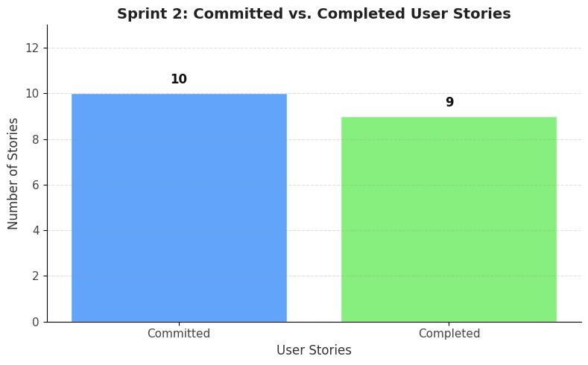

Fig 2.16 Committed vs Completed user stories sprint 2

From Figure 2.16, we can say that 9 out of 10 user stories execution has been done during the time of sprint 2.

**2.2.8 Sprint Retrospective**

Table 2.8 Sprint retrospective for sprint 2

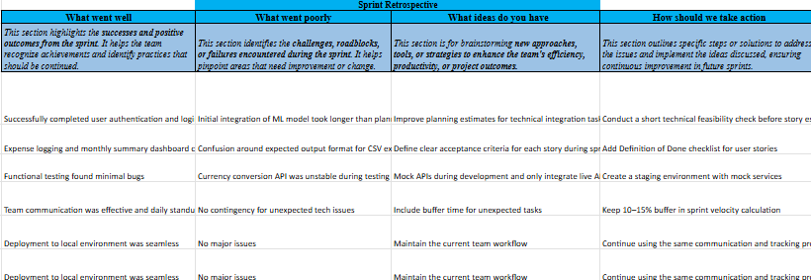

Table 2.8 represents the sprint retrospective we have done for the sprint 2

**CHAPTER 3**

**RESULTS AND DISCUSSION**

**3.1 PROJECT OUTCOMES**



Fig 3.1 login page

Figure 3.1 shows thw login page of our project which have fields to enter correct username and password



Fig 3.2 Expense logging

Figure 3.2 depicts the expense logging process in our project. It asks for amount description and other important information about the expense.



Fig 3.3 Expense Summary

From figure 3.3 we can see the expense categorization and it depiction in the expense summary section.

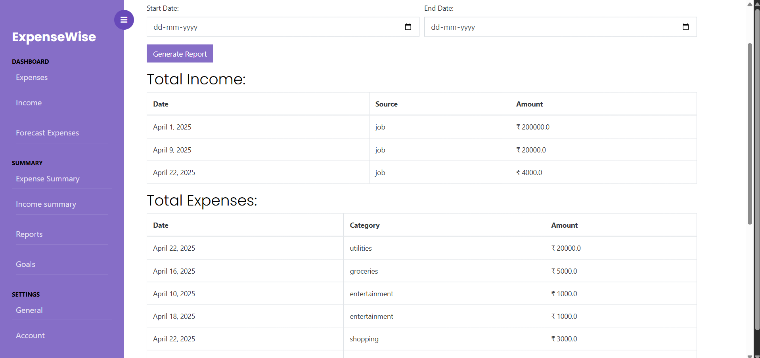

Fig 3.4 Expense Report

Figure 3.4 represents the expense report based on the income and expense logging which you have done earlier

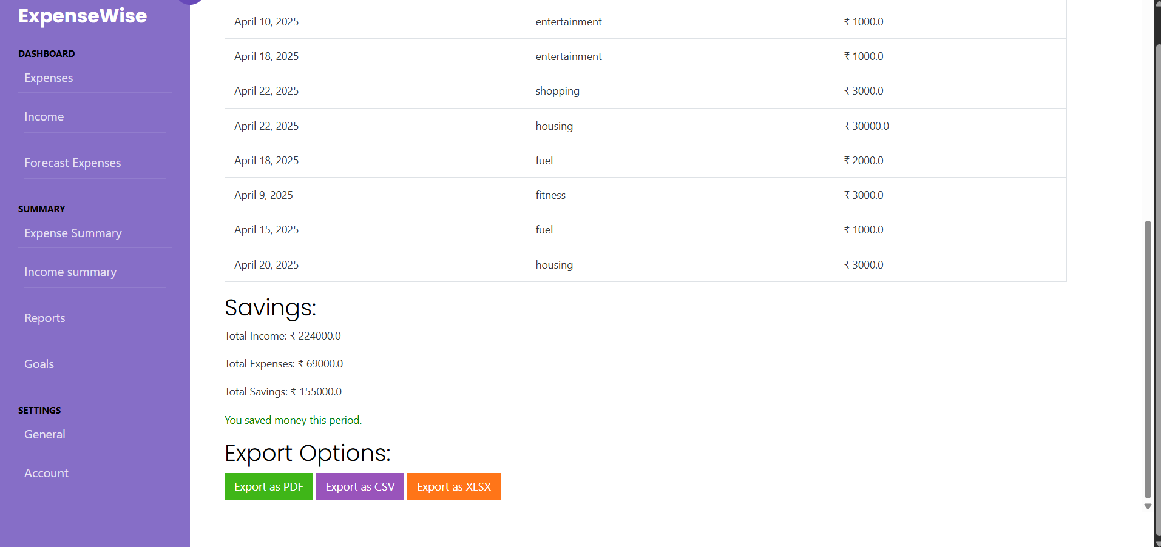

Fig 3.5 Report Export

From figure 3.5, we can see options to export the expense report of the data. User is given to export his data in pdf,csv and xlsx formats. 

Fig 3.6 Forecast Expense

From Figure 3.6, we can notice the forecast of our expense based on the historical data we provided.



Fig 3.7 Income Dashboard



Fig 3.8 Preferred Currencies

From fig 3.8 we can notice the different options for preferred currencies which help to track your expenses when you are out of the country.

**DISSCUSSIONS**

* Functional Outcomes: The Daily Expense Tracker successfully integrated AI-driven insights, multi-currency support, and expense sharing, allowing users to track spending, optimize budgets, and collaborate on joint expenses. Visualizations offer clear insights into spending patterns, improving decision-making.
* User Experience Outcomes: Users appreciated personalized AI insights and the intuitive interface. The expense-sharing feature was particularly popular for group management. Some users recommended refining AI insights for better accuracy and improving real-time currency updates.
* Technical Outcomes: The microservices architecture enabled scalability and efficient development. Real-time data exchanges and notifications functioned well, though performance issues occurred during peak usage. API optimization and infrastructure scaling will be essential for maintaining performance.
* Business Outcomes: The platform has proven valuable for both personal and group financial management. The combination of AI insights and collaboration features distinguishes it from other expense trackers, opening up opportunities for future partnerships and revenue streams.

**3.2 COMMITTED VS COMPLETED USER STORIES**

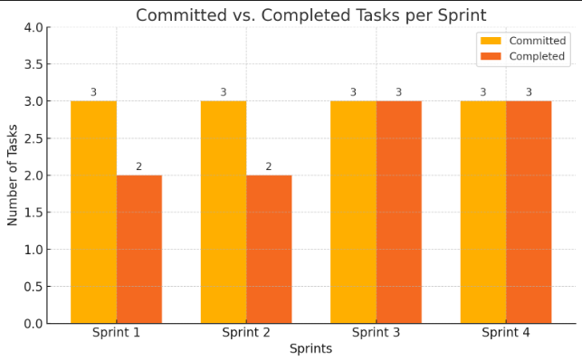

Fig 3.9 Committed Vs Completed User stories

From figure 3.9, we can see number of user stories which are aimed to commit and number of user stories completed over different sprints.

**CHAPTER 4**

**CONCLUSION & FUTURE ENHANCEMENTS**

CONCLUSION

The Daily Expense Tracker project successfully achieved its objective of providing users with an intuitive platform to manage their personal and shared expenses effectively. By leveraging AI-powered insights, multi-currency support, and real-time expense tracking, the platform has made significant strides in simplifying financial management for individuals and groups. The user-friendly interface and dynamic data visualizations have empowered users to make informed decisions, while features like expense sharing have fostered collaboration among users. The integration of robust security measures ensures that users' financial data remains safe and compliant with necessary regulations.

FUTURE ENHANCEMENTS

* Enhanced AI Insights: Further development of the AI model could improve the accuracy and relevancy of the expense forecasting and budgeting features, allowing users to receive even more tailored recommendations.
* Mobile Application: A mobile version of the platform could increase accessibility, allowing users to track expenses on the go and add expenses in real-time using their smartphones.
* Voice Recognition Integration: Incorporating voice commands for expense input could enhance user experience, particularly for hands-free data entry.
* Improved Currency Integration: Real-time exchange rates and better multi-currency support would ensure a seamless experience for users managing expenses across different countries.
* Collaborative Budgeting: Expanding the collaborative features to allow multiple users to jointly create and manage budgets could further enhance the platform's social and collaborative functionality.
* AI-Powered Fraud Detection: Adding AI-driven fraud detection algorithms could help identify and flag suspicious transactions, providing an added layer of security for users.

**APPENDIX**

**A.SAMPLE CODING**

